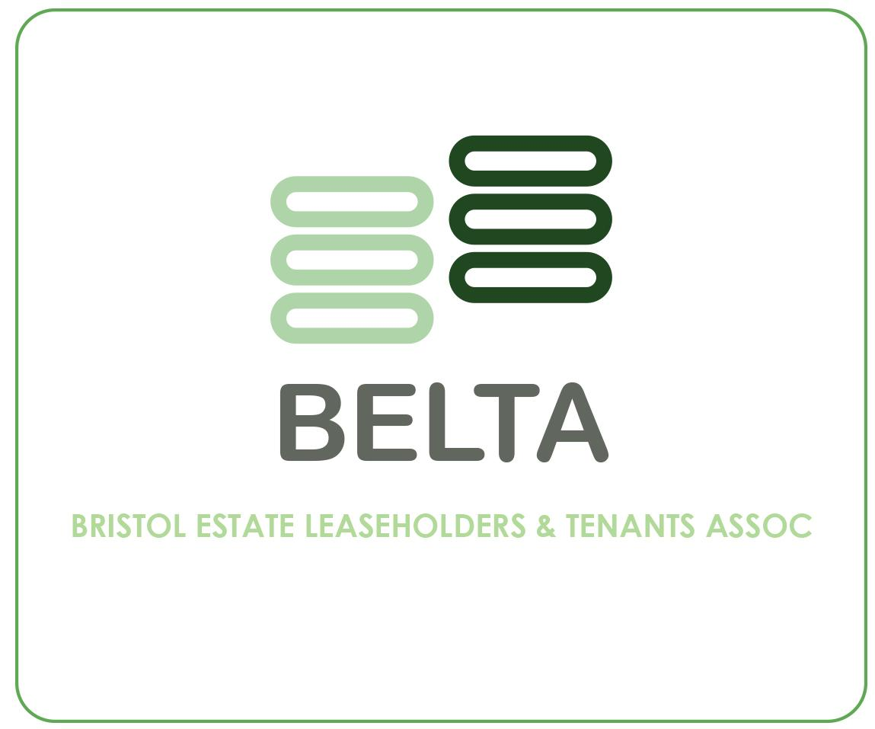
AGM NOMINATION FORM FOR Bristol Estate Leaseholders & Tenants Association (BELTA)
DEADLINE: for returning to the Independent Advisor:
Saturday 19th June 2021

I (name) ………………………………………………………..

of (address) ….………………………………………………..

……………………………………………………. Postcode: …………………………….

Telephone: …………… e-mail: ………………………………….

I would be interested in serving as a Trustee of BELTA and would like my name to be put forward for election at the Annual General Meeting.

Please only elect yourself for nomination if you are able to commit to attending meetings at least 4 times a year (Trustees). Help volunteering with Events and activity planning, support with fundraising for the Groups Aims and objectives and volunteer support to hold our AGM in 2022.

Signed ……………………………………………………….………………… Date: ……………...……

I have the following skills and experience which I feel would be useful to the Committee (e.g. Financial, Personnel, Activity or Events planning)

Please tell us, in no more than 100 words, why you wish to serve as a Committee Member:

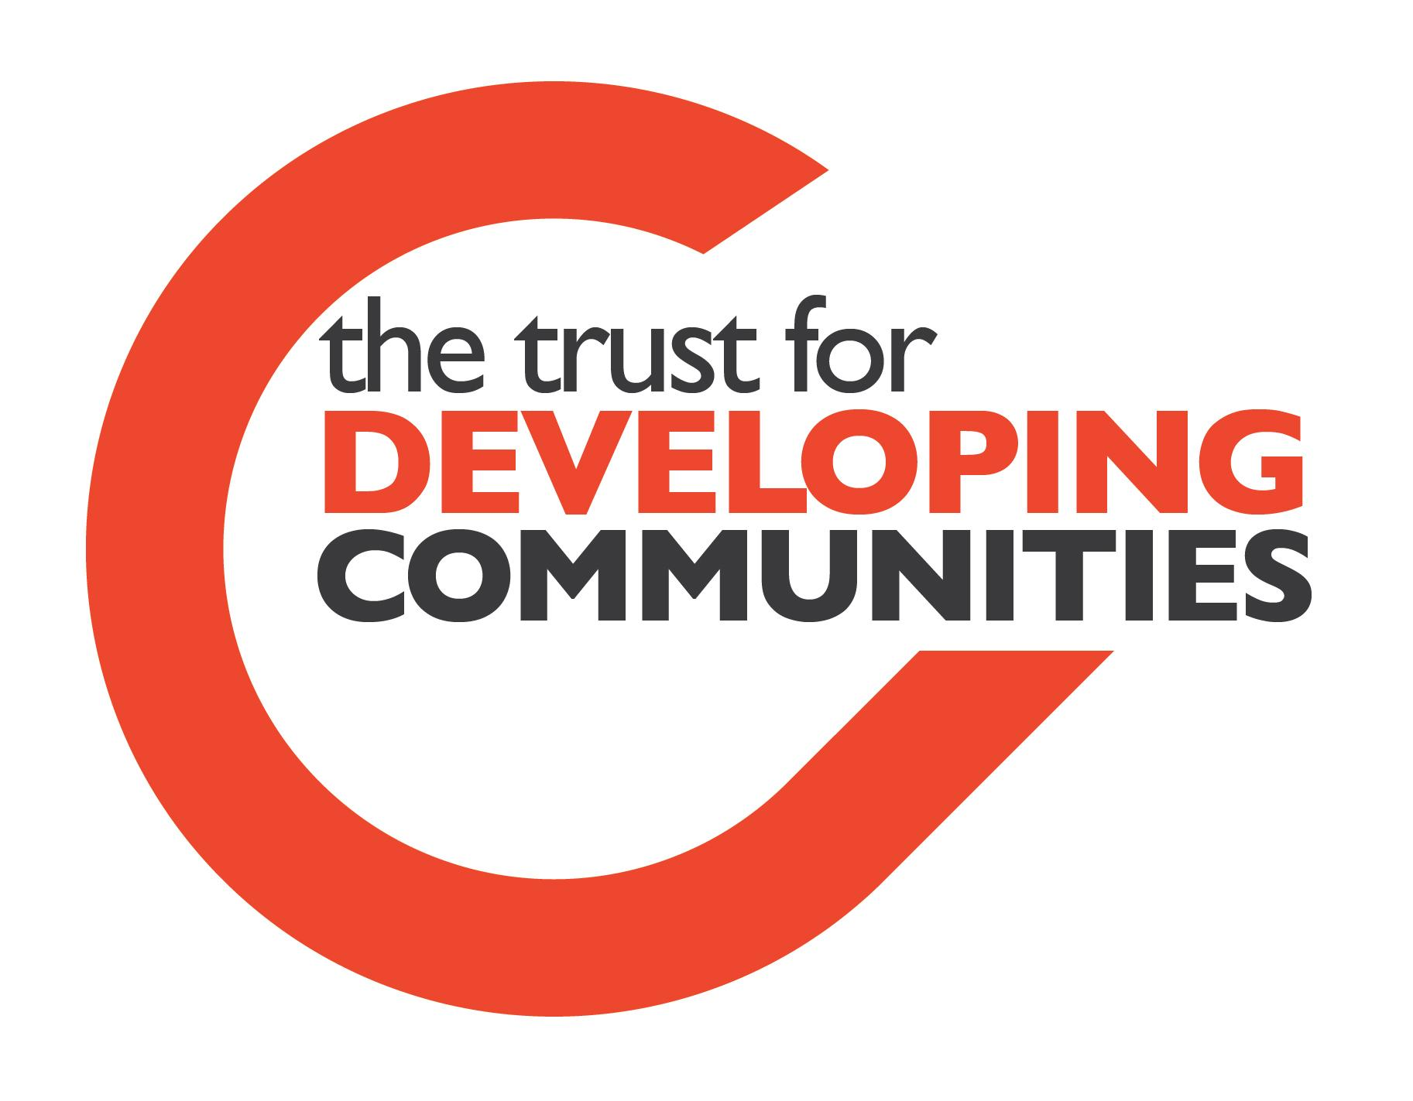
Please return this Nomination form to our Independent Advisor, Claire Burchell, Citywide Manager, The Trust for Developing Communities Postal address: The TDC, 113 Queens Road, Brighton, BN1 3XG – Please call Claire on 07809 829734 or return via email to claireburchell@trustdevcom.org.uk if you need support to fill in the nomination form please contact me.

